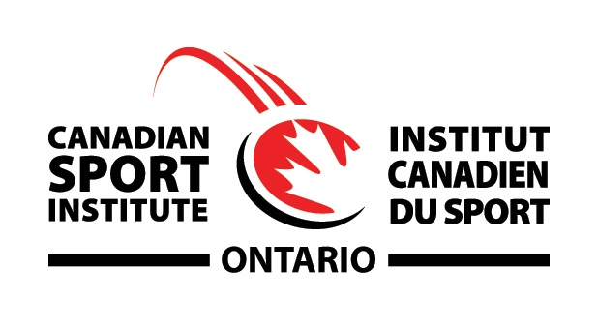

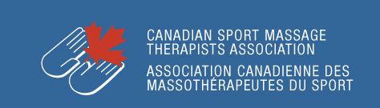

CSMTA and CSIO presents
2020 Sport Event Massage for Sport Specific Health Professionals

Developed by Certified Sport Massage Therapists. Their experiences range from treating at National and International sporting events. They also have been a part of the Integrated Support Team (IST) for Provincial, National, and Professional teams. Emphasis is placed on the practical component, supported by evidence and current best practices.
Techniques learned in this course can effectively and easily be transferable in both sporting event and clinical practice.
Time and tested protocols for event massage will be explained so that participants will leave with confidence in implementing them to their athletes.
The Participants will gain:
- A competency in techniques used in sport massage:
Compressions, cross-fibre massage, jostling, joint mobilization, effleurage and petrissage. A competency in the theory and techniques of pre-event, post-event and inter-event Sport Massage
- An effective protocol when covering an athletic event
- A quick and concise method of gathering useful information to make the Sport Massage session more efficient
- An understanding of the specific indications and contraindications for a variety of Sport Massage circumstances
- An understanding of the physiological and psychological effects of Sport Massage
- An appreciation on the value of Sport Massage Therapy’s role in the athletic environment
- Information based on the efficacy of Sport Massage

Course Date: Saturday February 8, 2020
Time: 8:00am Check-in. Course runs 8:30-6p.m.
Location: Canadian Sport Institute Ontario at the Toronto Pan Am Sports Centre 100-875 Morningside Avenue. Toronto ON M1C 0C7.

Co-Instructor’s Bios:
Remo Bucci RMT, CSMTA Sport Member
- Certified in Sport Massage since 2000, CSMTA Certification and Examination Chair since 2009, and Instructor for the CSMTA Advanced Sport Massage Course since 2010.
- Member of the High Performance Advisory Council Working Group for Own The Podium.
- Member of the IST for Swim Canada since 2014 and Cycling Canada (Indoor Track Cycling) since 2015. Supporting athletes in their daily training environment. Remo has supported athletes at the UCI 2019 World Track Cycling Championships.
- Member of Athletics Canada’s IST since 2010 where he supports athletes in their daily training environment as well as has supported athletes at: Summer Olympic game, 3 World IPC Championships, Senior and Junior IAAF World Championships, Pan Am and 2 Parapan Am Games.
- Member of the Canadian Core Medical Team, Remo has gone to:
2006 Winter Olympics, 2004 Summer Paralympics, 2003 Summer World University Games, and 2001 Summer Canada Games.
- Remo works at Canadian Sport Institute Ontario since 2014 as part of the Sport Medicine and Sport Therapy Team. Remo also works at Club Physio Plus in Oakville since 2002.
- Remo has taught Massage Therapy for 17 years. Remo focused his teaching in Treatments, Assessment, Remedial Exercise, and Anatomy. He incorporates what he has taught into his treatment sessions along with Osteopathic techniques, Active Isolated Stretching, IASTM, Cupping, Performance taping, and Thai Massage.

Mike Grastein RMT, R.Kin, CATA(C), CMRP, CSMTA Sport Member
- Certified in Sport Massage since 2012, CSMTA By-Laws and Policy Chair since 2014, CSMTA- Ontario Chapter Treasurer since 2018, and former CSMTA Board Member Secretary and PR Chair
- Instructor for the CSMTA Advanced Sport Massage Course since 2015.
- Certified Athletic Therapist since 1992, Registered Kinesiologist Since 2016
- CSIO casual Massage Therapist since 2015
- Massage Therapist with Swim Ontario - Current
- Former Head Therapist with Bryst International Soccer Academy 2000-2017
- Former Head Therapist with Ontario Soccer Association 1992-1994
- Host Medical Team - Athletics Para Pan Am Games 2015
- Member of the Canadian Core Medical Team for 2019 Summer FISU
- Mike divides his time between Balanced Body Breakthrough and Meridian Spine and Sport in Richmond Hill.
- Mike taught Massage Therapy for 12 years. Mike focused his teaching in Remedial Exercise, Physiology, and Anatomy. He incorporates what he teaches into his treatments plus his" finger-thumb" method and various direct and indirect myofascial techniques
Kristy Wiltshire RMT, BA KIN, CSMTA Sport Member
- Certified in Sport Massage since 2009, Registered Massage Therapist since 2006, Bachelors in Kinesiology and Physical education 2013 from Wilfrid Laurier University,
- Member of CSMTA Certification and Examination Committee, CSMTA National Office Coordinator/ Education Program Administrator since 2017
- Instructor for the CSMTA Advanced Sport Massage Course since 2011
- Clinic Student Supervisor for Kikkawa Massage College in 2017
- CSMTA BC Chapter President 2010-2012, CSMTA ON Chapter President 2012-2016, 2015-2017 National CSMTA PR Committee
- Casual Massage Therapist for Cycling Canada Next Generation (Indoor Track Cycling) 2019. Supporting athletes during their training camp environments. Kristy has supported athletes at the 2015 International track challenge and 2019 Canadian Track Cycling Championships (Elite and Masters).
- Member of Canadian Core Medical team for FISU Games 2011 and 2013
- Member of Host Medical Team for Winter Paralympic Game 2010, Pan Am 2015, and Ontario Summer Games 2012 and 2018
- Worked with Cavalia: Odyesso , and Cirque Du Soleil: Dralion Shows working and supporting athletes and performers in pre-performance and inter-performance sport massage
- Medical Volunteer Chair and Massage Lead for 2010 BC Summer Games
- Massage Therapist for Trinity Western University Varsity Teams 2007-2012
- Kristy Works at Burlington Sports and Spine Clinic since 2012 and Home-based Practice in Milton Ontario where she focuses on Rehabilitation, and Sports Massage.

Registration Information:

Go to csmta.ca to register

Course for Sport Specific Health Professional members of RCCSS(C), SPC, CATA, CASEM. Also, non-members who are Chiropractors, Physiotherapists, and Physicians that treat athletes of all levels are welcome to attend.
Participants must bring their linen, towels, and lotion. Wear loose fitting clothing, shorts, tank tops, sports bras. Lecture notes will be sent prior to the course for prereading.

Parking: $3.00 flat rate fee

EARLY BIRD REGULAR
Deadline: Before Jan 24th After Jan 24th
Members: $210 $230
Non-members: $230 $250
Breakfast with Coffee and Tea will be provided
*Proof of membership to the sport specific therapy/medical association is required at time of registration by emailing the information (i.e. membership card) to natoffice@csmta.ca

COURSE CANCELLATION POLICY
All cancellations must be received 7-days prior to the course and an Admin Fee of $50.00 will be retained. Non-attendance at a course or cancellations received with less than 7-days’ notice will not be eligible for a refund

